**WEEK-3**

**SOLUTIONS OF SPRING CORE and MAVEN**

**Exercise 1: Configuring a Basic Spring Application**

**Scenario:**

Your company is developing a web application for managing a library. You need to use the Spring Framework to handle the backend operations.

Sol->

1. Set Up a Spring Project**:**

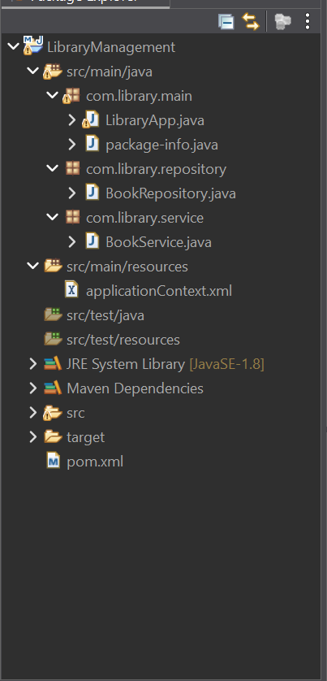

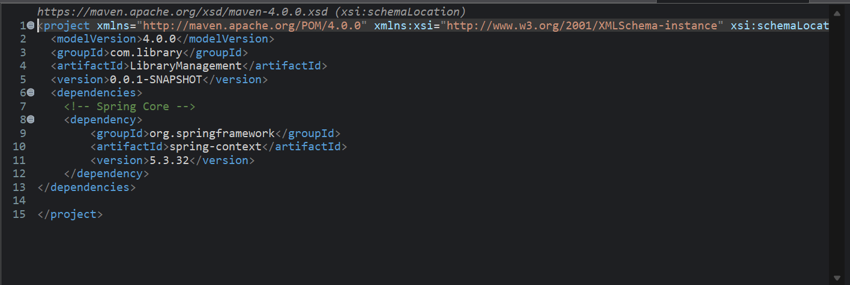

1. Configure the Application Context:



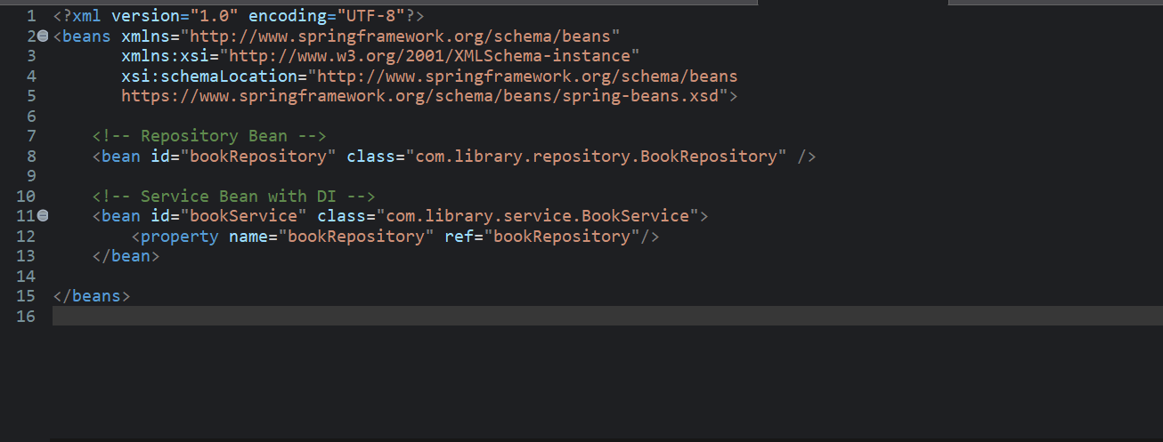

1. Define Service and Repository Classes:

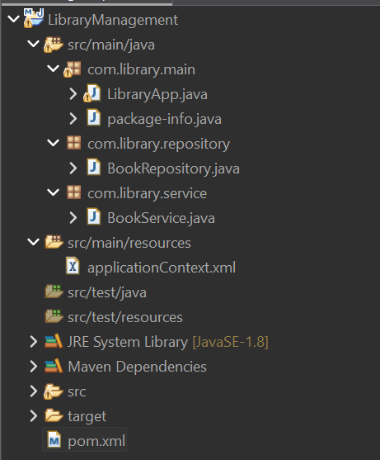

1. Run the Application**:**

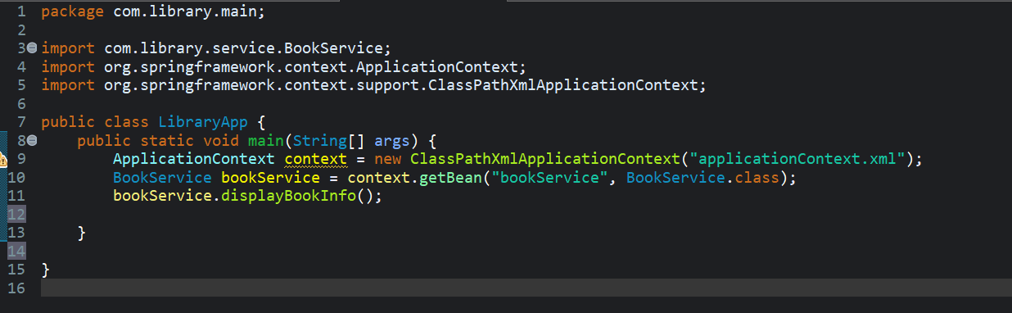

OUTPUT->

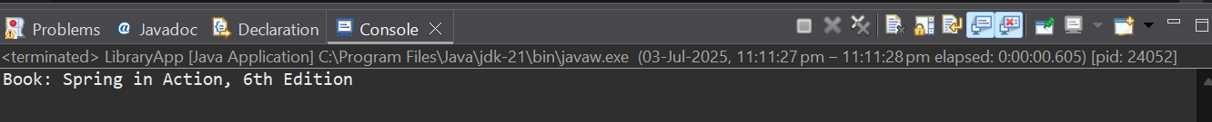

**Exercise 2: Implementing Dependency Injection**

**Scenario:**

In the library management application, you need to manage the dependencies between the BookService and BookRepository classes using Spring's IoC and DI.

a)Modify the XML Configuration:

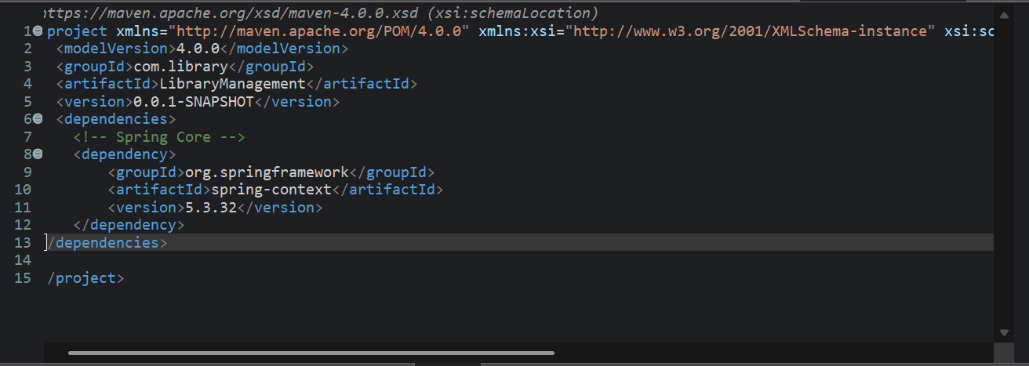

b)Update the BookService Class:

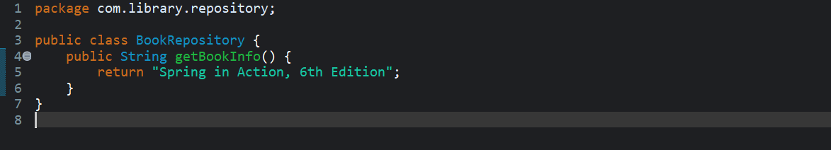

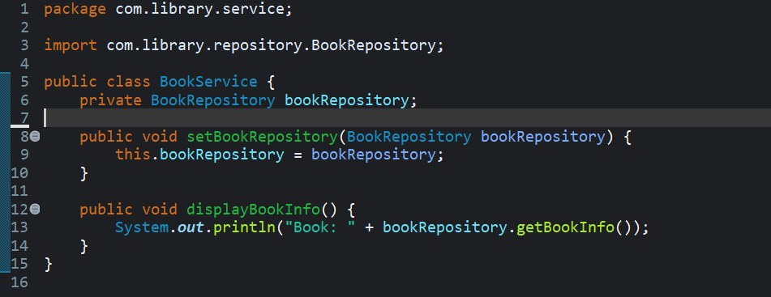

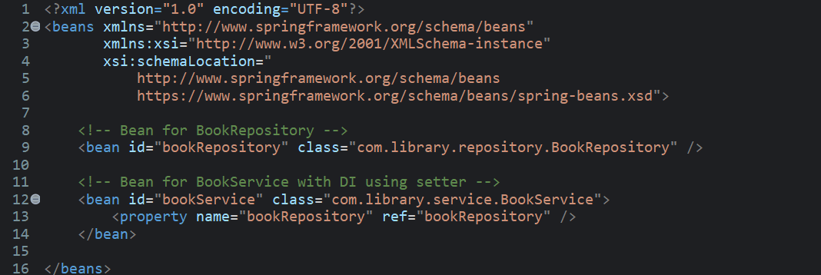

c)Test the Configuration:

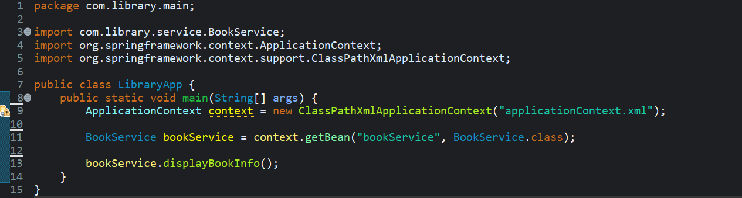

OUTPUT:

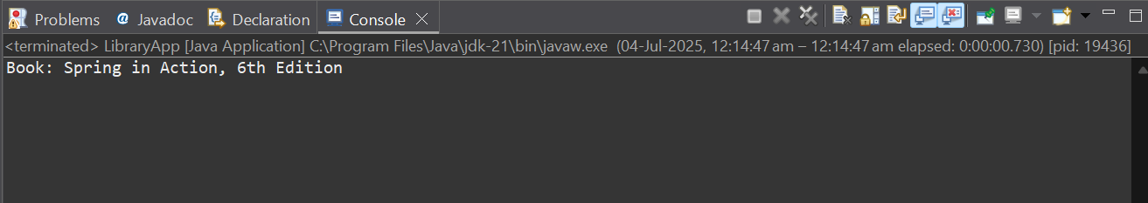

**Exercise 4: Creating and Configuring a Maven Project**

**Scenario:**

You need to set up a new Maven project for the library management application and add Spring dependencies.

a)Create a new Maven Project

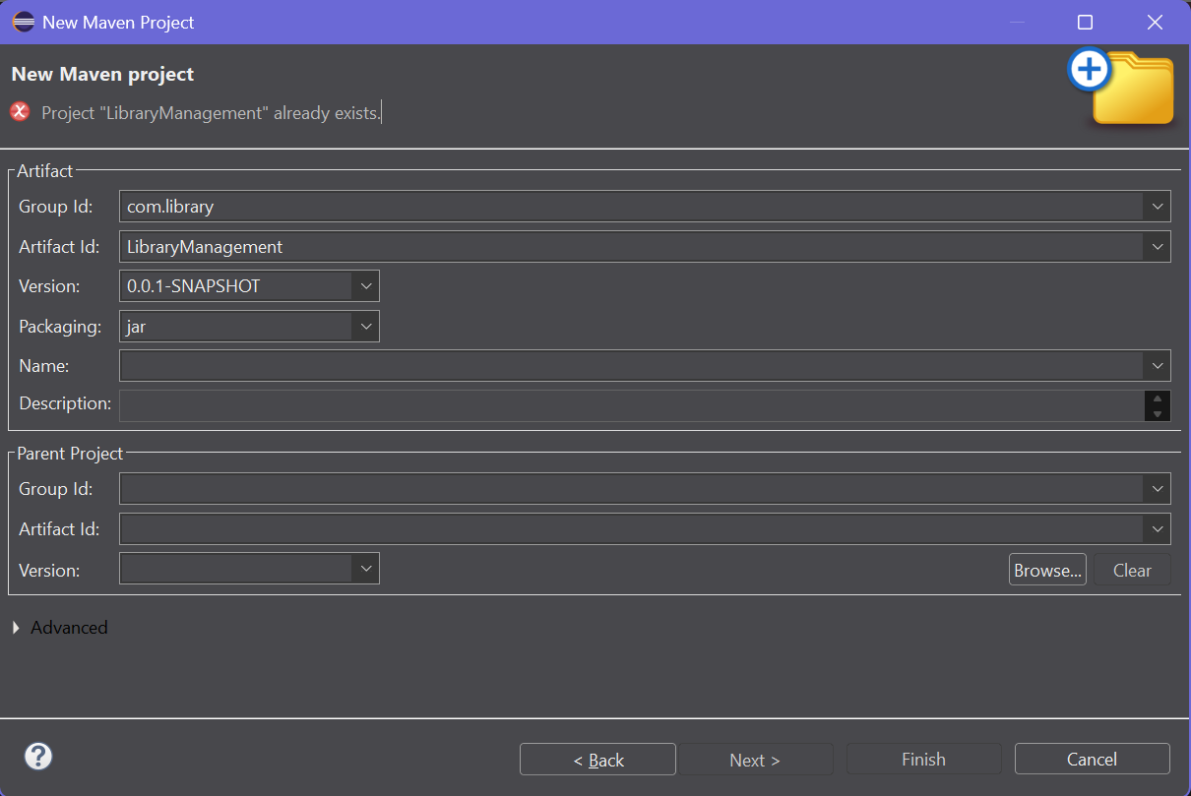

b) Add Spring Dependencies in pom.xml:

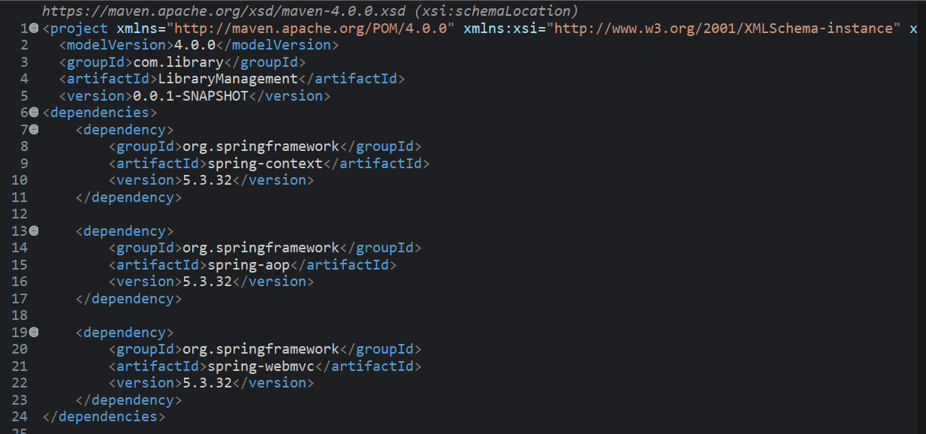

c) Configure Maven Plugins:

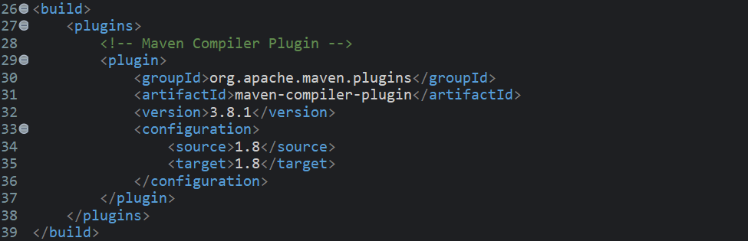Final pom.xml

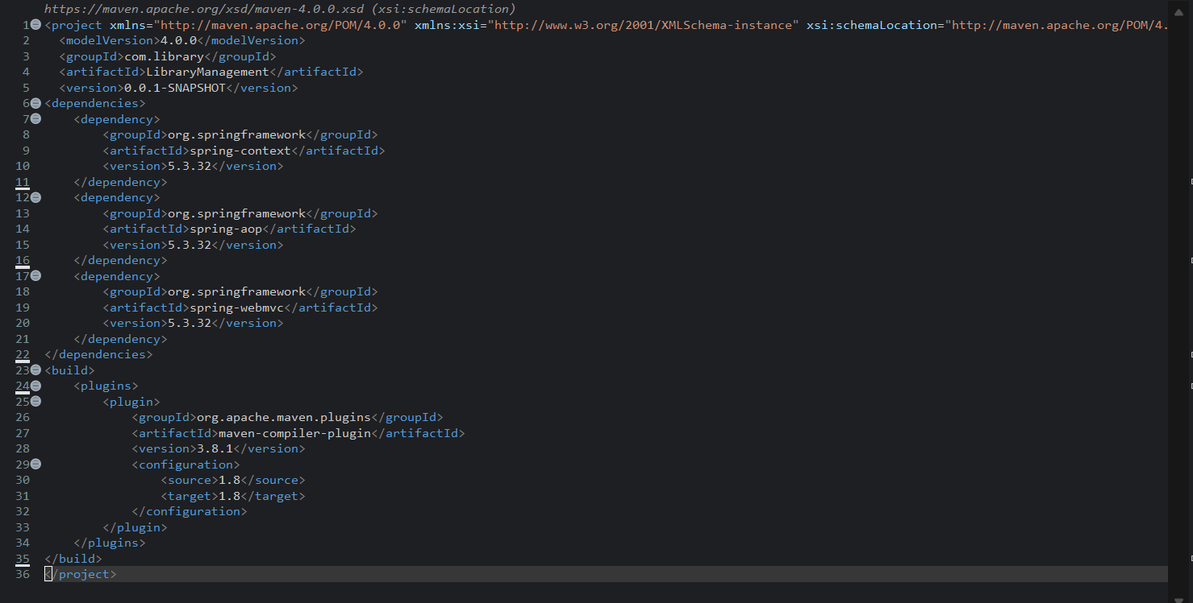

**Exercise 5: Configuring the Spring IoC Container**

**Scenario:**

The library management application requires a central configuration for beans and dependencies

Sol->

a)Create Spring Configuration File:



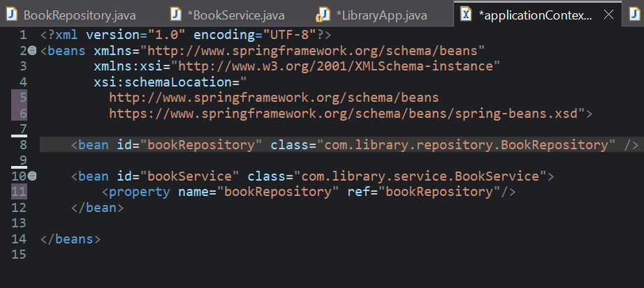

b)Update the BookService Class:

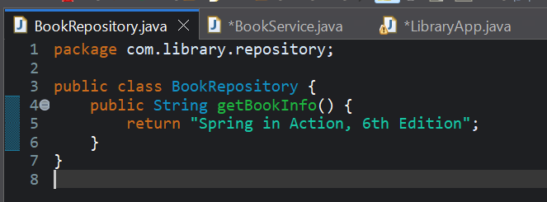

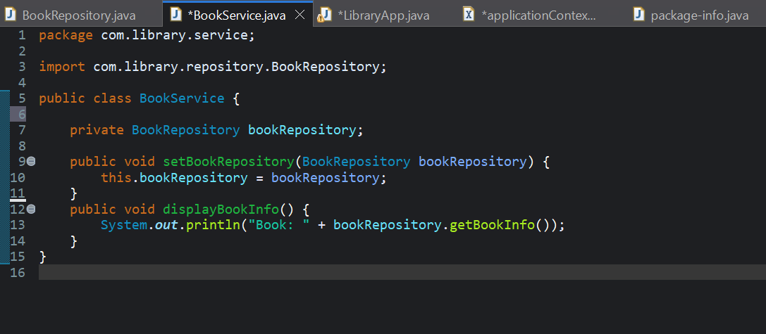  
c)Run the Application**:** 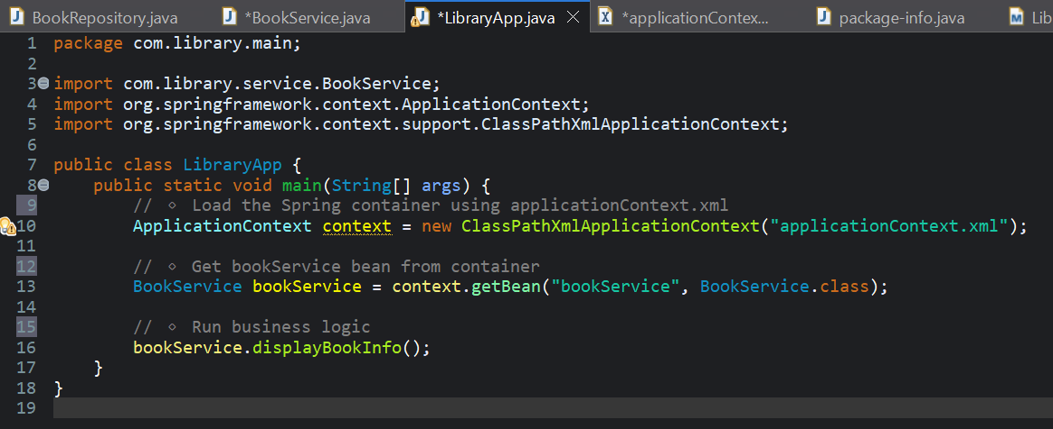

OUTPUT:

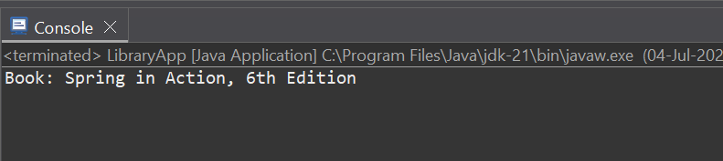

**Exercise 7: Implementing Constructor and Setter Injection**

**Scenario:**

The library management application requires both constructor and setter injection for better control over bean initialization.

1. Configure Constructor Injection:

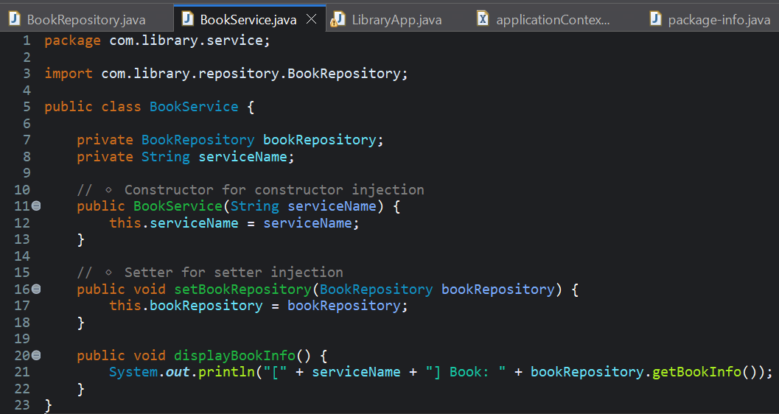

b)Configure Setter Injection:

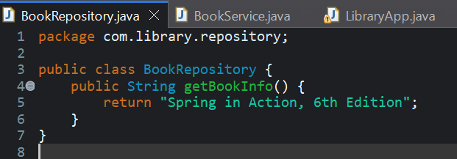

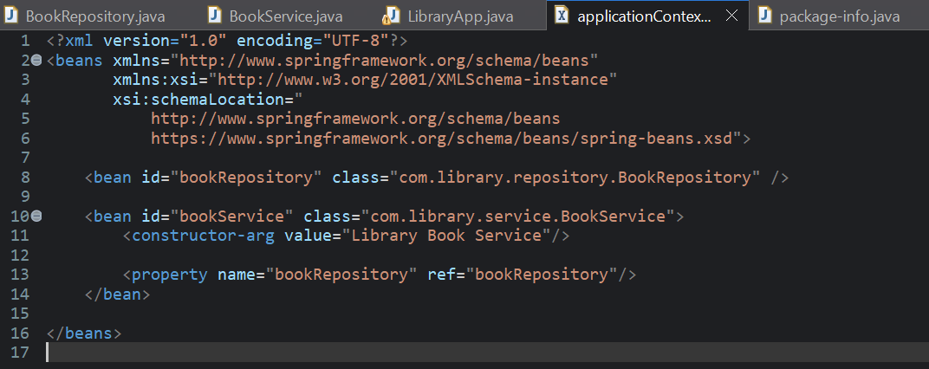

c)Test the Injection:

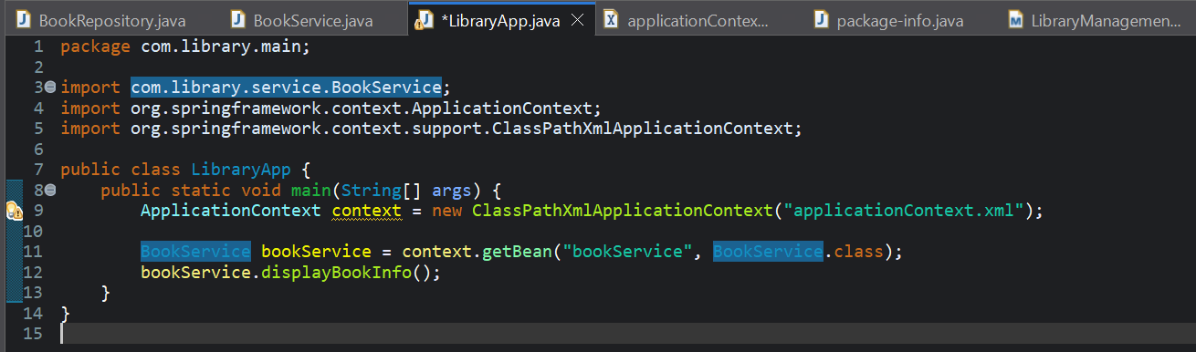

OUTPUT:

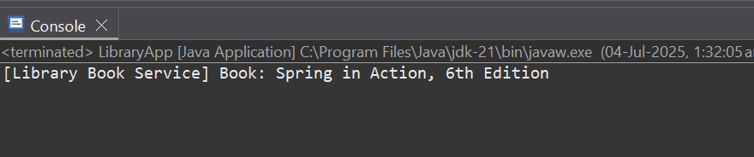

**Exercise 9: Creating a Spring Boot Application**

**Scenario:**

You need to create a Spring Boot application for the library management system to simplify configuration and deployment.

Sol->

a)Create a Spring Boot Project:

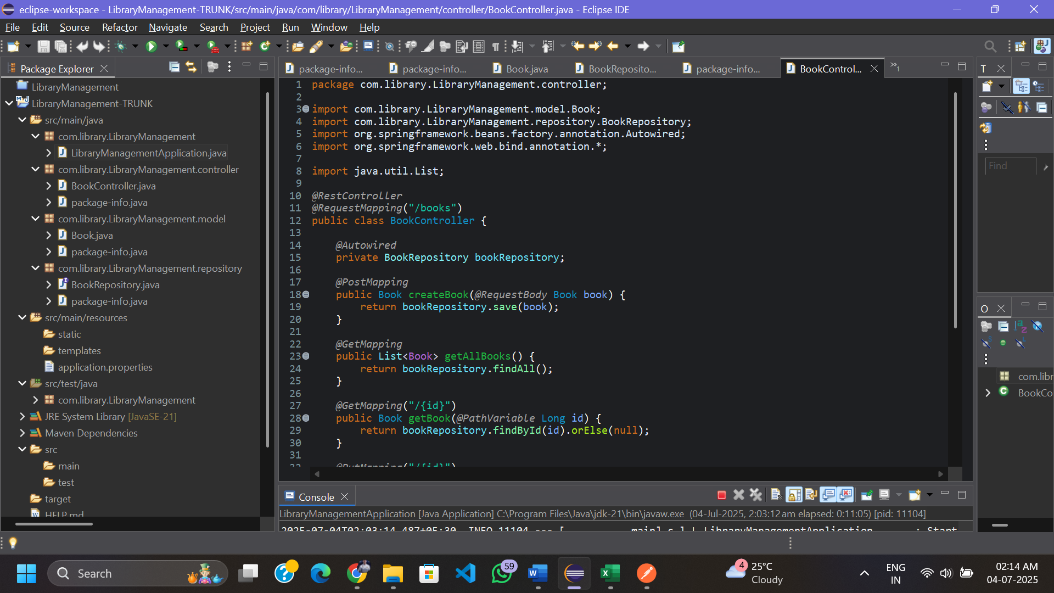

Project structure->

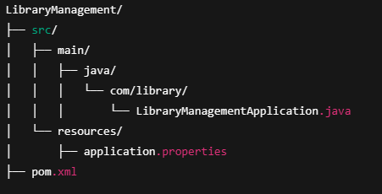

1. Add Dependencies:

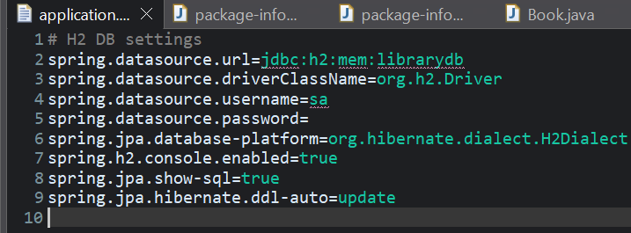

c)Create Application Properties:



d)Define Entities and Repositories:

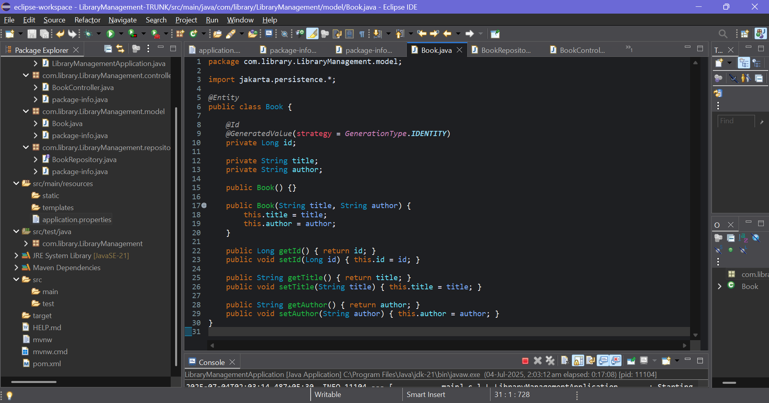

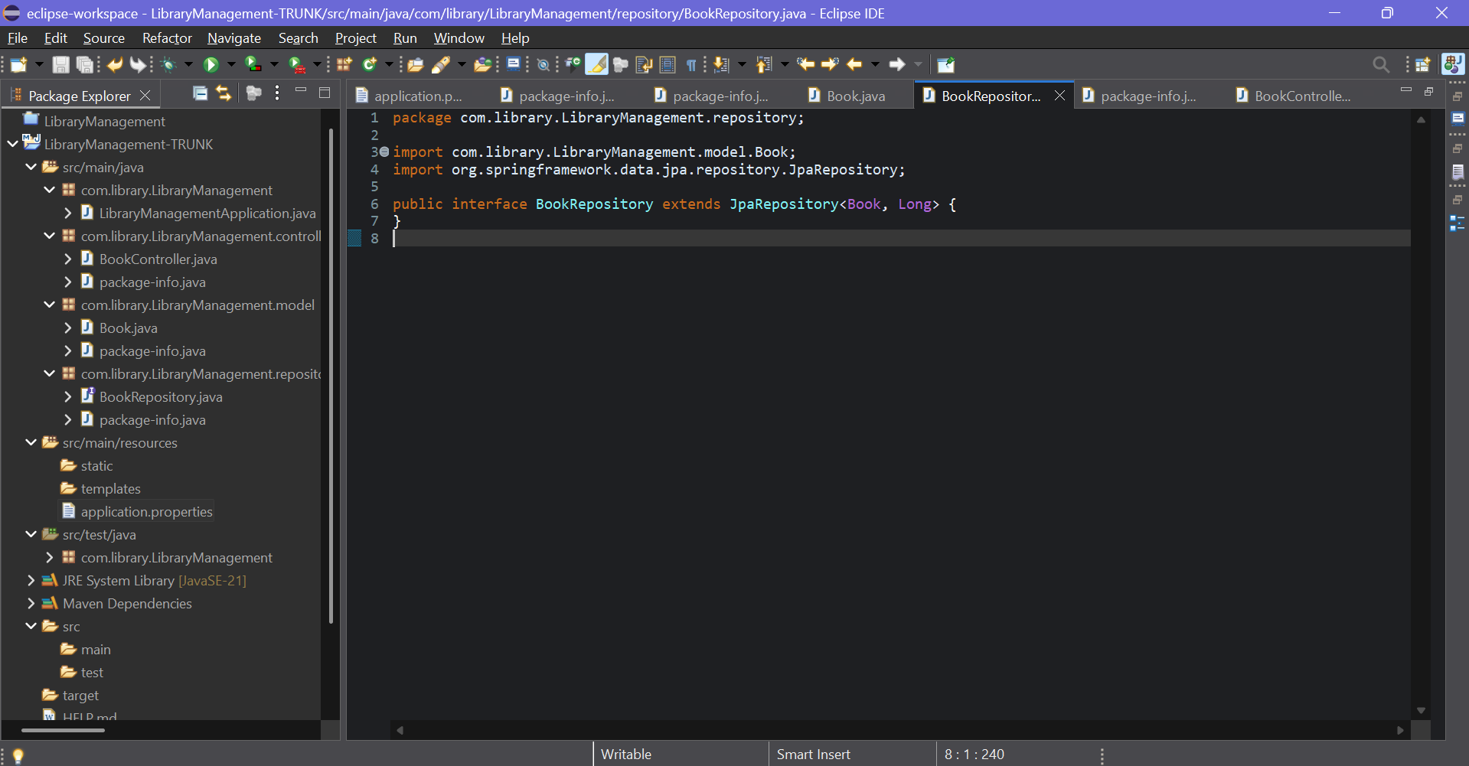

1. Create a REST Controller:

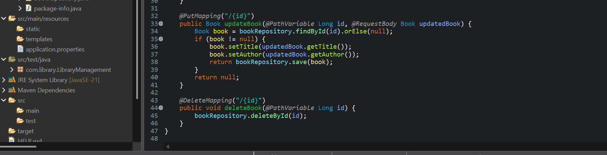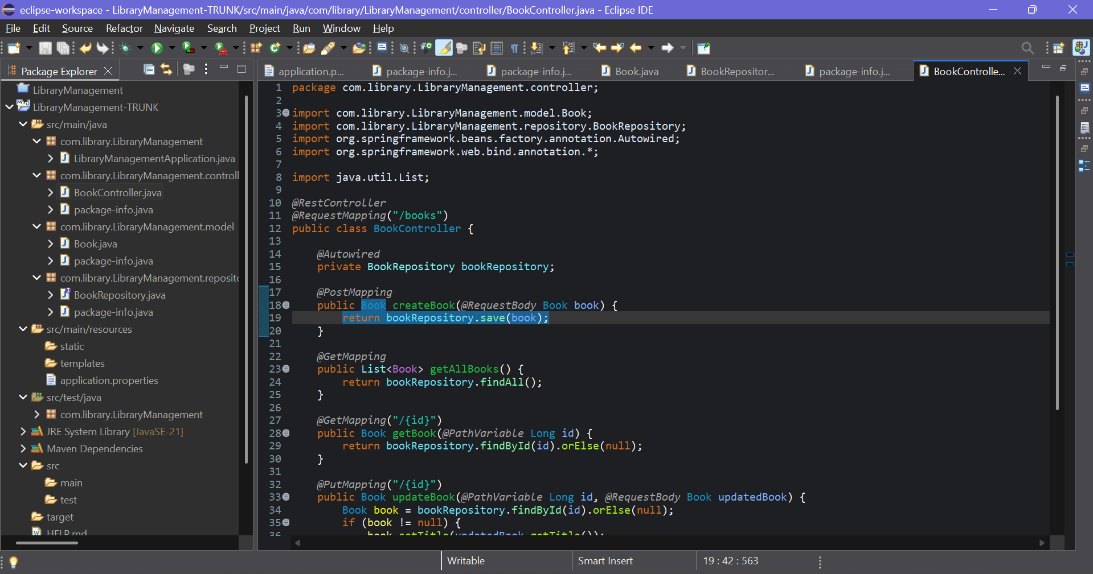

f)Run the Application

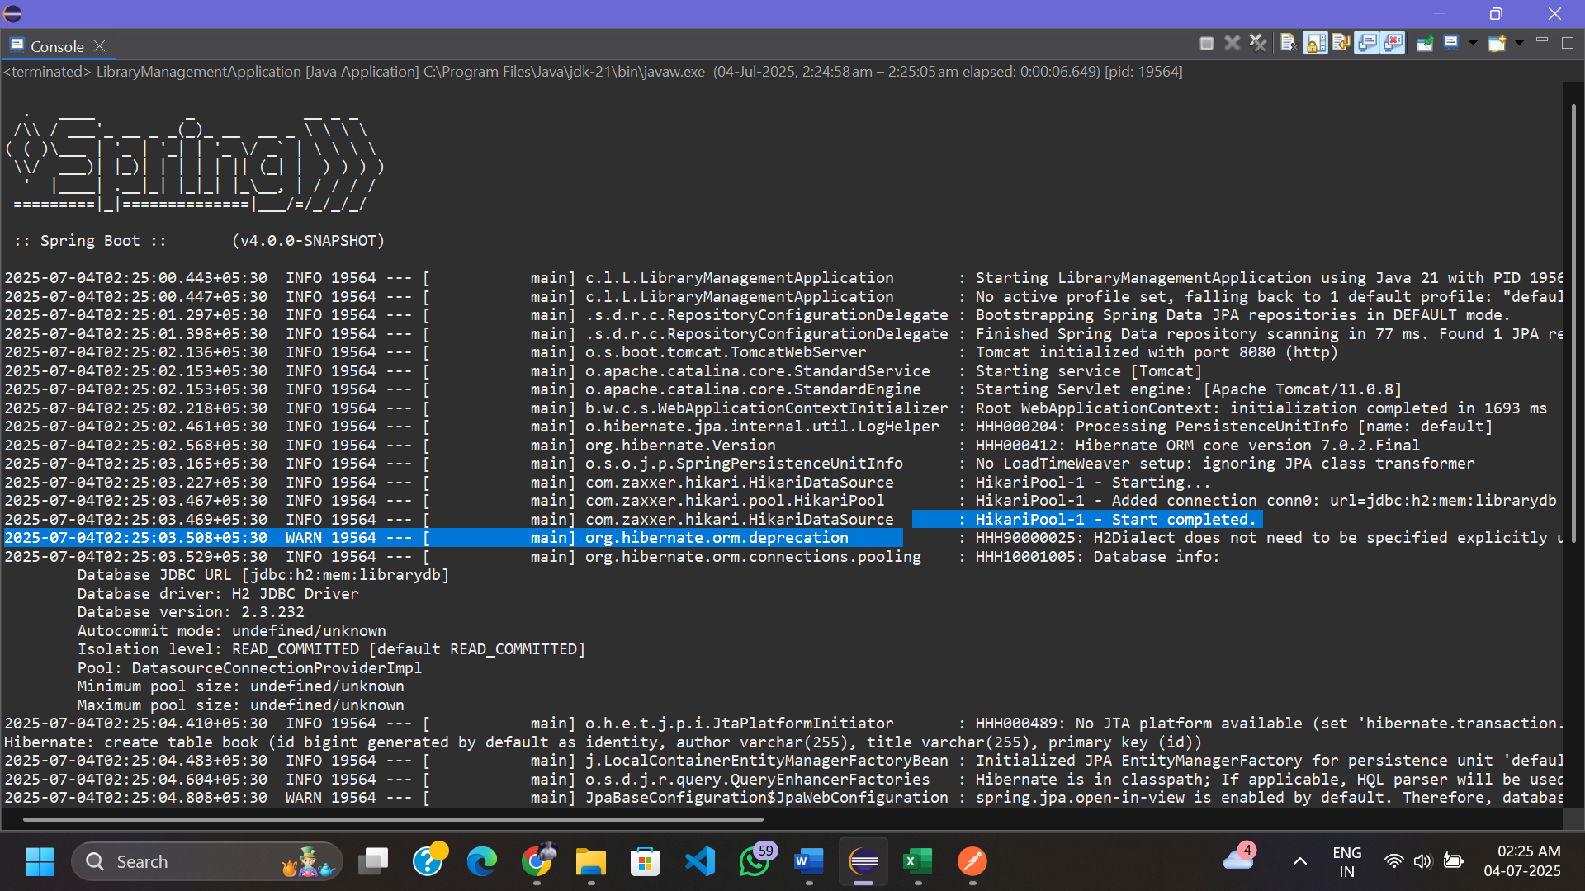

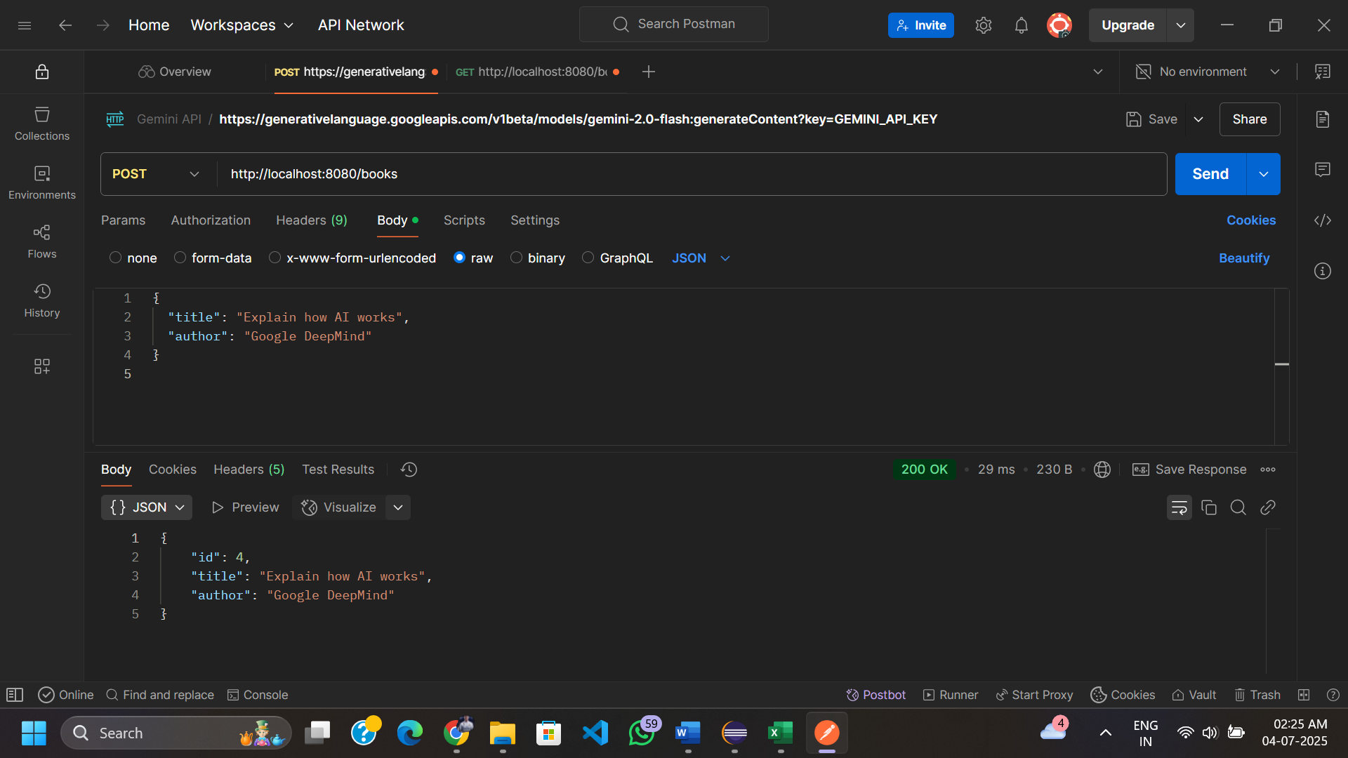

Using Postman for performing and checking the CRUD operations.